A

PROJECCT REPORT

**On**

**“Project Title”**

**School / Student Attendance Management System**

**Submitted by**

**Name of the student**

**Janhavi Jaishankar Hiremath**

**Class: MCA II Year**

**Guided By**

**Name of the Guide**



**SSBES’S**

**Institute of Technology & Management Nanded**

**Affiliated to**

**Swami Ramanand Teerth Marathwada University, Nanded**

**2022-2023**

**CERTIFICATE**

**This is to certify that the project report entitled**

**as**

**“Name of the project”**

**SCHOOL / STUDENT ATTENDENCCE MANAGEMENT SYSTEM**

***Submitted by***

**Name of the student**

**Janhavi Jaishankar hiremath**

**In partial fulfillment for the Degree of M.C.A. Course**

**at**

***“Institute of Technology and Management, Nanded”***

***Affiliated to***

***Swami Ramanand Teerth Marathwada University, Nanded.***

**2022-2023**

PA Kadam sir

Mr/Mrs./Miss

**Project Guide**

Dr. M.M. Bokare Dr. S.B. Thorat

**Head of Dept. Director**

**2022-2023**

**ACKNOWLEDGEMENT**

The success and final outcome of this Project required a lot of guidance and assistance from many people and I am extremely privileged to have got this all along the completion of my Project. All that I have done is only due to such supervision and assistance and I would like to extend my sincere thanks to all of them.

I am highly indebted to **Name of the guide** for her/his guidance and constant supervision as well as for providing necessary information regarding this project & also for her/his support in completing the same.

I would like to thank **Dr. S. B. Thorat**, Director, SSBES’s Institute of Technology and Management, Nanded for providing me an opportunity to do this work in Institute of Technology and Management, Nanded and giving us all support and guidance.

Also I would like to thank **Mr. M. M. Bokare**, HOD, Dept. of Computer Science, for his encouragement and more over for his timely support and guidance till the completion of Project work.

I would like to express my gratitude towards my parents their kind co-operation and encouragement which help me in completion of this project.

My thanks and appreciations also go to my friends in developing the project and people who have willingly helped me out with their abilities.

Janhavi j hiremath

**Name of the Student**

**2022-2023**

STUDENT ATTENDANCE MANAGEMENT SYSTEM

1. Introduction:-

* The main purpose using computerized system is to avoid manual problems and also documentation storage problem we can’t maintain long period data that’s why we used computerized system to overcome all problem related to school’s data storing and other arias.
* This website handles online student admission procedure.
* Hillfort public school is a web based project that maintains all the activity related to school. This project works on dynamic website handling.
* project show time to time event information related to school. It also provides the facility for sending mail to parent regarding student activity.
* The proposed website controls student information and faculty details.
* This is web based project it’s provide privilege facility for security purpose and provide login facility according to designation and restrict unauthorized used, if user is not admin then it can’t access everything, this project provide four type of designation facility and access permission.
* We can generate report according to date & show all report also; Because of manual system we faced many problems. The maintenance cost of manual system was very high. And they didn’t store historical information and not possible to view all at a time.
* This web site reduces the time & cost and provides the facility to retrieve student all information according to requirement.
* School event and all activity related information display on this web site, the school related latest news display on this site
* School related all information display on this project.

**2. Objective:-**

School is web based project that is maintain all the activity related to School, it store all the information of student, project show time to time event information related to school, project provide the facility

* To provide student detailed information and faculty details.
* To make admission procedure fast and easy.
* To inform student with time to time event information and notices.
* To inform parents about student activities through email.
* To generate separate student and faculty login Id and password.

**3.1 Feasibility Study:-**

A procedure that identifies, describes, and evaluates candidate systems and selects the best system for the job is called as Feasibility study.

Three key considerations are involved in the feasibility analysis:

1. Technical Feasibility
2. Economic Feasibility
3. Operational Feasibility

**1. Technical Feasibility:-**

The use of CSS and .NET makes form design easy and convenient. The project can be run on any system with minimum requirements. It reduces data entry errors because of data entry validation, it can be easily handled by any user, and it also helps in faster data updations. Also the project though developed in GUI, it is very easy to operate. Hence the project is technically feasible.

**2. Economic Feasibility:-**

Cost benefit analysis is very important in deciding whether the project is economically feasible or not. Itis alone sufficient to save our time and money. It is one time investment and does not require regular maintenance. Through cost benefit analysis it was concluded that the benefits outweigh costs and thus the project is economically feasible.

**3.** Behavioral Feasibility**:-**

Behavioral feasibility determines how much effort will go into educating, selling and training the user staff on a candidate system. The project was also evaluated to be behaviorally feasible as it is very user-friendly and hardly needs any extra efforts to educate user for its utility and functioning.

**3.2 Present System in use:-**

The present system consists of static web pages and do not allow dynamic insertions of data. Hence there is a need to create a dynamic website.

* System can be web-based so that everyone can easily interact with system.
* System can provide optimize functionality.
* System can be customizable so that one can update it.
* System can be flexible enough so that it can incorporate different changes time to time.
* The most important thing is security. All the data should remain consistent and secure.

**3.3 Software Requirement Specification**: -

School administrator wants to build the system that technically and economically strong and helpful to company progress. He wants to reduce large man-power involved in company to perform the task that high company cost and slow company work. For future use all documents are kept in written or in a file in secure manner. If a file gets lost it cannot be retrieved in any way. A large storing area is required to store the data manually.

The purpose of software requirements specifications is to provide a framework that enables the manager to take reasonable estimates of resources, cost and schedule. These estimates are made with a limited time frame at the beginning of a software project and should be updated regularly as the project progresses. In addition estimates should attempt to define best case and worst case scenarios so that project outcomes can be bounded.

To gather the requirement of client’s need, we take the idea about the data flow from other school websites and also refer documents of school.

**3.4 Flaws in present system / Need for new system:-**

* Present system is a totally manual system which lacks security and is time consuming. This is not user friendly
* The data is recorded manually, which is error prone and often leads to confusion.
* A lot of file work had to be done for storing information like student details, faculty details.
* There may be possibility of delay in managing whole admission process.
* Also certain information redundancy may occur then it will become a hurdle to management

**3.5 Proposed System:-**

This site is an attempt to make the task of administrator easier. This project ensures the consistency by enabling the parents to register themselves and to find the desired information about school time table, notices, event schedule and many more.

The administrator has the right to know everything. He has the right to know the details of the student and faculty, has the right to change any information that the website is currently providing.

The administrator can also contact the parents through email to state his child activities. Aim of this project is to provide an environment helpful for administrator, faculty and parents to obtain information. This project is developed after a thorough study of the existing manual system.**3.6 Project Category:-**

This is web based project. This project developed for business purpose. It provides the batter facility for student to check all the information related to exam information and study material.

This project provides the user id to student for check online events and notice.

It provides online admission facility and main objective of this project is increase the admission of school and know everyone about the school and it facility.

While using this application Client will get to know the quality of education that is delivering in school. **4.1 Software Engineering Process Model used:**

The waterfall model shows a process, where developers are to follow these phases in order:

1. Requirements specification (Requirements analysis)
2. Software Design
3. Integration
4. Testing (or Validation)
5. Deployment (or Installation)
6. Implementation & Maintenance

**I. Requirements Specification**:

A Software Requirements Specification is a complete description of the behavior of a system to be developed. It includes a set of use cases that describe all the interactions the users will have with the software.

We studied the requirement and specification provided by client & list out all the functional requirement of website that would be implemented from our side. We also suggest client some good functionality like contact import.

**II. Software design:**

Software design is a process of problem solving and planning for a software solution. After the purpose and specifications of software are determined, software developers will design or employ designers to develop a plan for a solution.

We have divided the project into small modules and plan how we can design and implement the module as per the client expectation. First we have plan a database scheme of project, which would help us to go in correct flow, we have also design the DFD (Data flow design) to implement the website.

**III. System integration**:

System integration is the bringing together of the component subsystems into one system and ensuring that the subsystems function together as a system. In information technology, systems integration is the process of linking together different computing systems and software applications physically or functionally, to act as a coordinated whole. We have complete knowledge of all interfaces that would include on our website. It includes interfaces between Modules, Database, Server, and between the other system API (Application program interface), which would work with. For a system to be successfully implemented and used, the elements like DB, files/function must be in place and functioning correctly.

**IV. Software testing:**

Software testing is an investigation conducted to provide stakeholders with information about the quality of the product or service under test. Software testing also provides an objective, independent view of the software to allow the business to appreciate and understand the risks of software implementation. Test techniques include, but are not limited to, the process of executing a program or application with the intent of finding [software bugs](http://en.wikipedia.org/wiki/Software_bug) (errors or other defects).

We have checked the accuracy, completeness, consistency, spelling and accessibility of website. These areas are the first things judged by the user. Users must have the best possible experience with our website. For browser compatibility we have tested the website in all browsers to make sure the graphics and other objects on a website would be displayed same. To check all of these modules, test browsing needs to be done. The purpose of this test is to find flaws in the navigation of the web pages.

**V. Software deployment**:

Software deployment is all of the activities that make a software system available for use. The general deployment process consists of several interrelated activities with possible transitions between them. These activities can occur at the producer site or at the consumer site or both. Because every software system is unique, the precise processes or procedures within each activity can hardly be defined. Therefore, "deployment" should be interpreted as a *general process* that has to be customized according to specific requirements or characteristics.

After implementation & testing of whole website on local server, we have deployed the website on main server to get ready for launch. The client has provided their server details along with database details. We transfer (uploaded) files from our local server to the main server through ftp(file transfer protocol), also run the sql file in asp.net file to import the database , then we configure the file for database connection to run the system on main server.

**VI. Implementation & Maintenance:**

The Maintenance phase is the longest phase of the SDLC. In this phase the software is updated to:

-Fulfill the changing customer need.

-Adapt to accommodate change in the external environment.

-Correct errors and oversights previously undetected in the testing phase.

-Enhance the efficiency of the software.

**4.2 Modules and Modular Charts:**





Login

Student Login

Student Admission

Faculty



**4.3 System Flow Chart:**

Subject

Attendance

Courses

School attendance management system

Student Login

Database

Report

Student Admission

courses

Other Activities

Create User Account

Student

Admission table

Courses Table

Other activity table

**5.1 Data Structure, File Design / Table:**

**Student Admission:-**

The student admission table stores the StudentID ,Class, UserType, pwd, NameOfStudent, Mothertounge, NameOfFather, Occupation, Mobile, ResidencePhone, ResidenceAddress, Email, City etc

**Other Activity:-**

The Other Activity table stored OtherActivityID, OtherActivityName, Date etc.

5.2 Data Flow Diagram:-

A dataflow diagrams shows the functional relationship of values computed by a system, including input values, output values and internal data stores. It is a graphical representation showing the flow of data values, contains processes, data flow, actor objects, and data stores. Data Flow Diagram (DFD) is one of the first tools used to model system components. The components of DFD’s are the system processes, the data used by processes, any external entities that interact with the system and the information flows in the system.

0 levels DFD:

User Login

Process

Server

User

Response

Response

**Figure:** 0 Level DFD

**1st level DFD:**

**Student attendance management system**

**Student**

Retrieve data

Admission form info

Student Admission

courses

Other Activity

Generate Report

Notice info

Other Activity info

Save & retrieve student information

Save & retrieve Notice

Save & retrieve other activity

**Figure:** 1st level DFD

**5.3 Entity Relationship Diagram:-**

Make

Has

Student admission

Attendencce

Other activity

**Figure:** ERD

**5.4 Modularization details:**-

In any Company many projects are going on at a particular time. Each project is divided into various modules depending upon the work. Each Module depends upon the work. Each module is depending upon the task it does has got various forms, reports etc.

**Student information:**

**I. Student Admission:** Basically it contain whole information of student regarding to student admission form, in this form required information like name, class, gender, user id and password of student and required mandatory field.

**II. Courses:** this table information hold courses of School related

**III. Other Activity:** this specified the other activity of student like id course attendance etc.

**5.5 Data Dictionary:**

**Student Admission:**

ID Name Courses Batch Attendence

01 smithj BA 1t Year A present

02 john BA 1st yr B present

03 riya BBA 1st yr A present

04 raj BBA1st yr B present

05 gaurav BSC 1st yr A present

**Home page:**

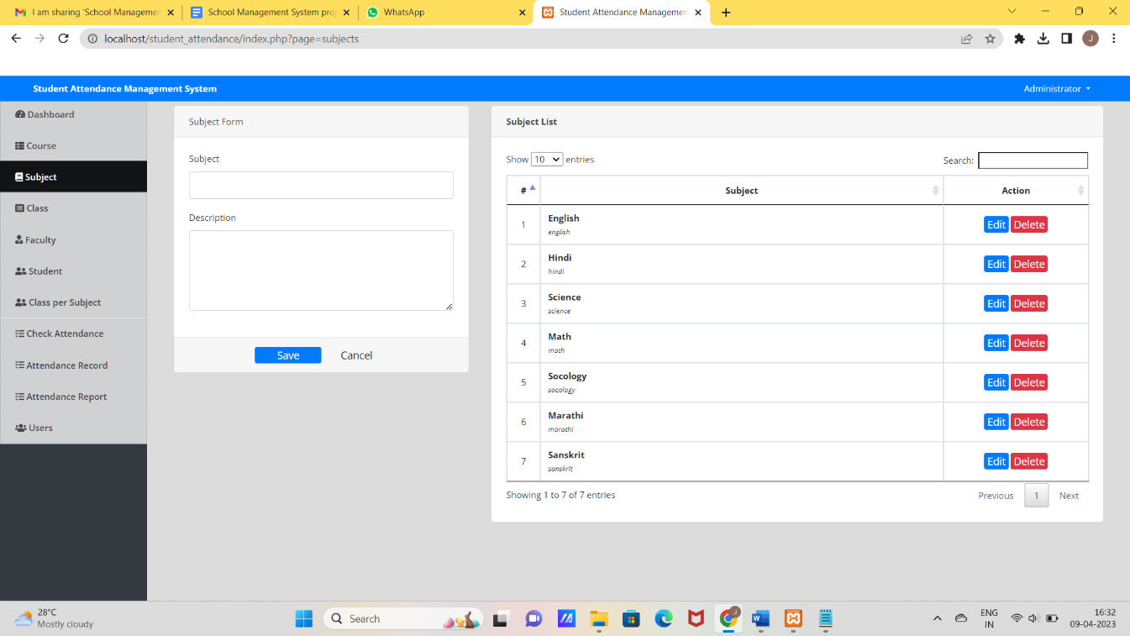

**Login form:** Student login

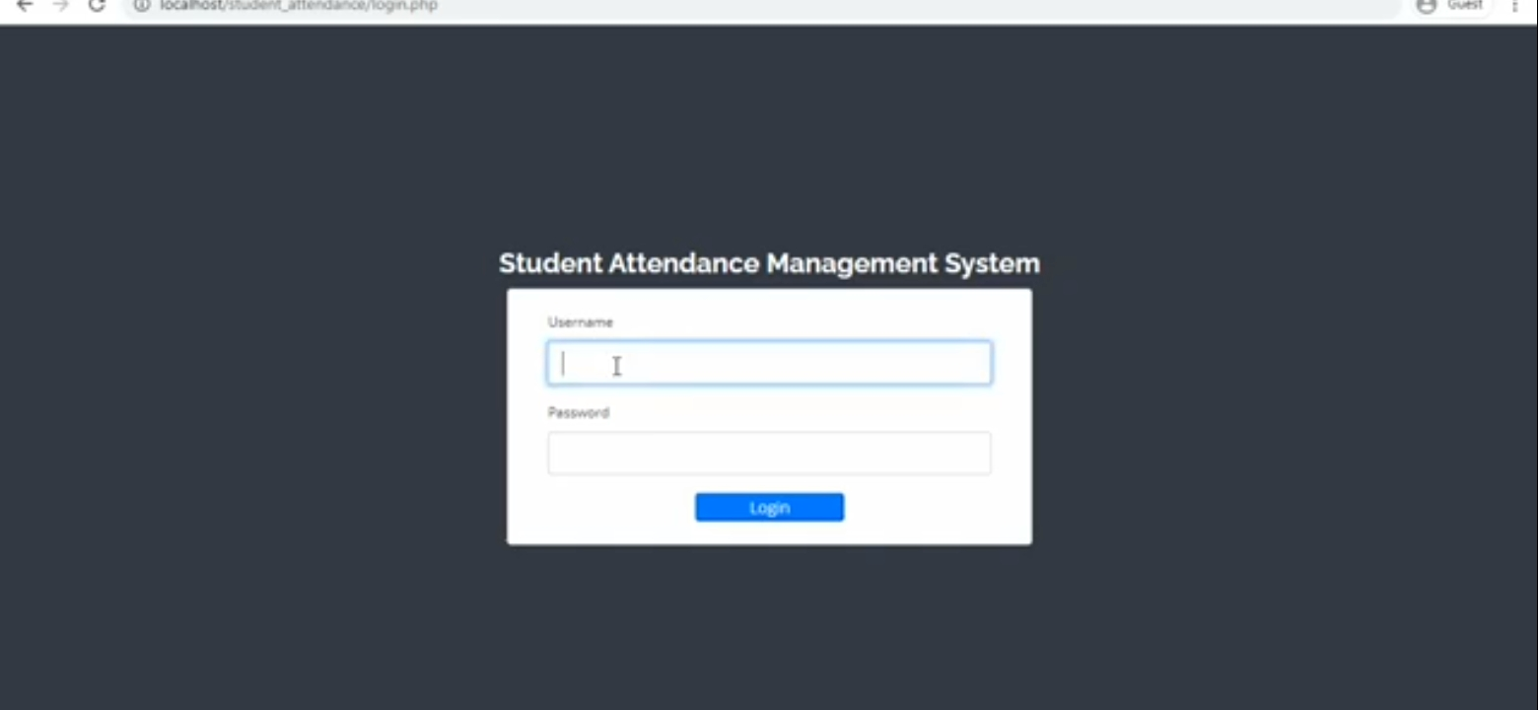

**6. Validation Checks:**

Under validation we have provided certain constraints and primary keys to few fields of the tables of the database used in application. This validation made at database level is listed below:

* **Required Field Validation**: we use require field for fill the information compulsory in the project without this validation the data will not be submitted in the project
* **Numeric only**: Numeric only constraints restrict field to have numeric values only. Otherwise it violates the rule.
* **Character only**: It restricts the field to accept only character value.
* **Date:** The valid date with valid format should be enter in the given textbox.
* **Email:** The @ Symbol is required in this field otherwise it will not work properly.

**7. Implementation:-**

Domain Names: Based on requirement, we will need to pick out a Domain Name. While a domain name that uses words that summarize the site or services are good for school administrator, which help us in deciding the domain name and getting it registered.

Hosting: We have to take a space on server for our files so the website would be access through internet.

**I. Site Category & Layout**:

The message to get across to the viewer quickly and easily. We have take the time to determine what’s the main theme or message is to be, then break that theme or message down into categories. Which will help guide us through this process and help determine a site format that loads

**II. The Size Website:**

Normally it’s best to keep our first website to a minimum size. Not only is it less costly, but this allows administrator to grow as the web base clientele increases. We add, change and substitute new information, pages, links, and text as the business and site progresses. Starting with a basic website leaves the room to grow and change as the circumstance dictates.

**8. Testing:**

There are various types of web application testing without which we cannot say that the complete system is properly working. Some of the most important web testing has been mentioned below:

**Unit Testing:** Unit testing happens at the development level. When a developer builds a piece of code that delivers a set of functionality, they must test it to make sure it works and that it delivers the required functionality. A developer tests by running the code in their own environment. A piece of code (be it a web page or a function) should never go into a systems integration environment until it has been unit tested.

|  |  |  |  |  |
| --- | --- | --- | --- | --- |
| **No.** | **Test case Title** | **Description** | **Expected Outcome** | **Result** |
| 1 | Successful start up of the application and the login menu being present to take the user to login prompt | The menu is clicked | The login prompt should come up | Passed |
| 2 | Select the user type | Select the appropriate user type i.e. administrator, faculty and student | Ask for username and password | Passed |
| 3 | Registration of Admin | Click on the login button. | The appropriate admin panel will appear | Passed |
| 4 | Update user information | Click edit button | The update page should come with user information | Passed |
| 5 | Delete User | Click delete button | Message should come “whether you want to delete user” and after clicking yes user should be deleted | Passed |

**System integration testing (SIT):** A systems integration environment is a test environment where code (web pages, classes, databases) is placed to ensure the application as a whole works together. Usually there’s more than one developer building an application or site. Each one unit tests their individual functions and pages, and one a regular basis, their code is deployed into the SIT environment and tested together. This ensures one developer’s code doesn’t break the others. Usually test cases and test scripts are developed based on the functional requirements and tested here. It provides a more integrated view of the application. This is also the environment that gives a mirror of the production environment. Most applications live with other applications in production. This is the first chance to ensure that the new application/site doesn’t break and isn’t broken by other sites or applications in the same environment.

**Table:** Testing table**9. Evaluation:-**

Evolution processes are multi-level, multi-loop, multi-agent feedback systems. This phase is basically based on the client what they want to update in the software. In the project evaluation the main thing is how the project will work in the client-side or server-side, and how much better performance in the system. The project is web based application so it will be do proper work in the client side and properly interact with the hardware.

**Steps to Evaluate**

* Install the software on a clean system.
* Check for proper operation of software.
* Check for .dll file conflicts.
* Check for registry entry problems.
* Check for file conflicts.
* Create Application item.
* Push application to test station and check for proper operation.

After performing all the above steps it is justified as project has been implemented successfully.

**10. Security Measure Taken:-**

To understand what measures are taken for security of application, first we need to understand what kind of threats penetrates the security of application. Errors and omission, disgruntled and dishonest employees, external attacks and natural disasters.

.

**i) Authentication:-**

System checks the password under the particular user identification. The computer permits the various resources to the authorized person.

**ii) Authorization:-**

The access control mechanism to prevent unauthorized logging to the system.

**iii) Form authentication**

The Form authentication collects user's credential and lets the application use own logic to authenticate users. The collected user's credential is validated using the list maintained by the application. The application maintains its own user list either using <credential> element in the web.config file or using database. The advantage of using form authentication is that the users don't need to be the member of windows network to have access to the application.

* school students but in future it can be utilized for middle school, high school and colleges by some minor modifications.
* Database may be available in future for long times and information may be use anytime.
* SMS facility in future

**13. Conclusion:**

The conclusion of Student Attendence Management System is to construct such dynamic website which will provide information about school activities such as admission system, event schedule, courses important notices and dignitary messages.

Towards the end of the student attendance management system I would like to say that the target, which was initially set up, was achieved to a good extent. The project made me realise the significance of developing software for client, where the sole aim is to learn.

During the Hill fort Public School project, the real importance for following all principle of system analysis and design dawned on me. I felt the necessity of going through the several stages.

As we done the initial investigation, now we can say that this application possible to create. But as project will progress there may some change in functionality of the project.

**14. Bibliography:**

Following books are referred for developing this project:

1. “ASP.NET COMPLETE REFERENCE”, MCGRAW-HILL EBOOKS

**By HERBERT SCHILDT**

1. “SOFTWARE ENGINEERING”, SIXTH EDITION, TATA MC GRAW HILL

**By ROGER S. PRESSMAN**

1. “DATABASE SYSTEM CONCEPTS”, FIFTH EDITION, TATA MC GRAW HILL

**By HENRY F. KORTH**

1. SYSTEM ANALYSIS AND DESIGN

**By ALIAS M. AWAD**

**Website visited:**

1. www.msdn.microsoft.com
2. www.projectcode.com
3. www.plus2net.com/sql_tutoria
4. www.W3Schools.com for CSS Tutorials
5. http://forums.asp.net